**Report: Data Analysis and Visualization for Market Expansion Strategy**

**Executive Summary**

I have conducted a comprehensive analysis of the provided datasets to facilitate strategic decision-making for the company's expansion efforts. Our objective was to compare various parameters across different countries, including income, life insurance share, market share, penetration, ratio of reinsurance accepted, and retention ratio. The analysis involved the use of two datasets, the Primary Dataset (Insurance Sample Dataset) and the Secondary Dataset (Global Financial Development Database).

**Data Sources**

* Primary Dataset: Insurance Sample Dataset
* Secondary Dataset: Global Financial Development Database

**Methodology**

The analysis involved several steps, including data blending, visualization, and the creation of an interactive dashboard. Below are the key steps and findings:

**1. Geographic Map Visualization**

A geographic map was created to visualize countries around the world. The map was color-coded based on the income column from the secondary dataset. This visualization helps us understand the income distribution across countries and identify potential target regions for expansion.

**2. Income Group Filter**

An income group filter was included in the dashboard, allowing users to filter and segment countries based on income levels. This feature provides flexibility in focusing on specific income brackets during the analysis.

**3. Webpage Integration**

A webpage was integrated into the dashboard, which displays data from the World Bank webpage. This integration was driven by an URL action triggered by selecting a country on the geographic map. Users can access additional information about each country via this feature.

**4. KPI Table for Comparison**

A Key Performance Indicator (KPI) table was created to compare selected parameters between the chosen period and the prior one. Users can select the year and category (life insurance share, market share, penetration, reinsurance ratio, or retention ratio) to view relevant comparisons. The KPI table dynamically updates based on user selections.

**5. Growth Indicator Shapes**

Growth indicator shapes were introduced to visually represent growth trends. These indicators display values such as "Negative," "No Change," or "Positive" alongside corresponding shapes. Users can quickly assess growth patterns for different parameters.

**6. Trend Line Visualization**

A trend line chart was added to the dashboard, providing users with a visual representation of the selected category's values over time. To enhance clarity, an arrow or triangle was included at the last data point on the trend line, indicating the latest trend direction.

**7. Dashboard Filter for Income Group**

A dashboard filter for income groups was implemented and applied to all charts and visualizations. This interactive feature ensures that users can analyze data for specific income groups across all elements of the dashboard.

**8. Formatting and Aesthetics**

The dashboard was formatted to ensure a visually appealing and user-friendly interface. Proper labels, titles, and legends were included to enhance readability and comprehension.

**9. Screenshots of the Dashboard**

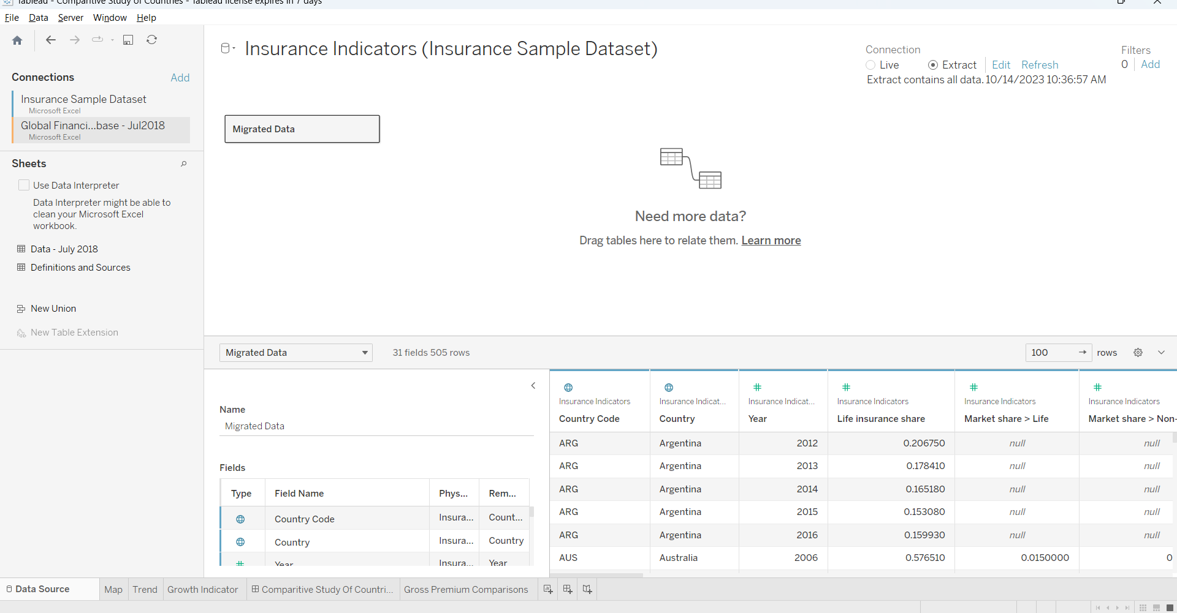

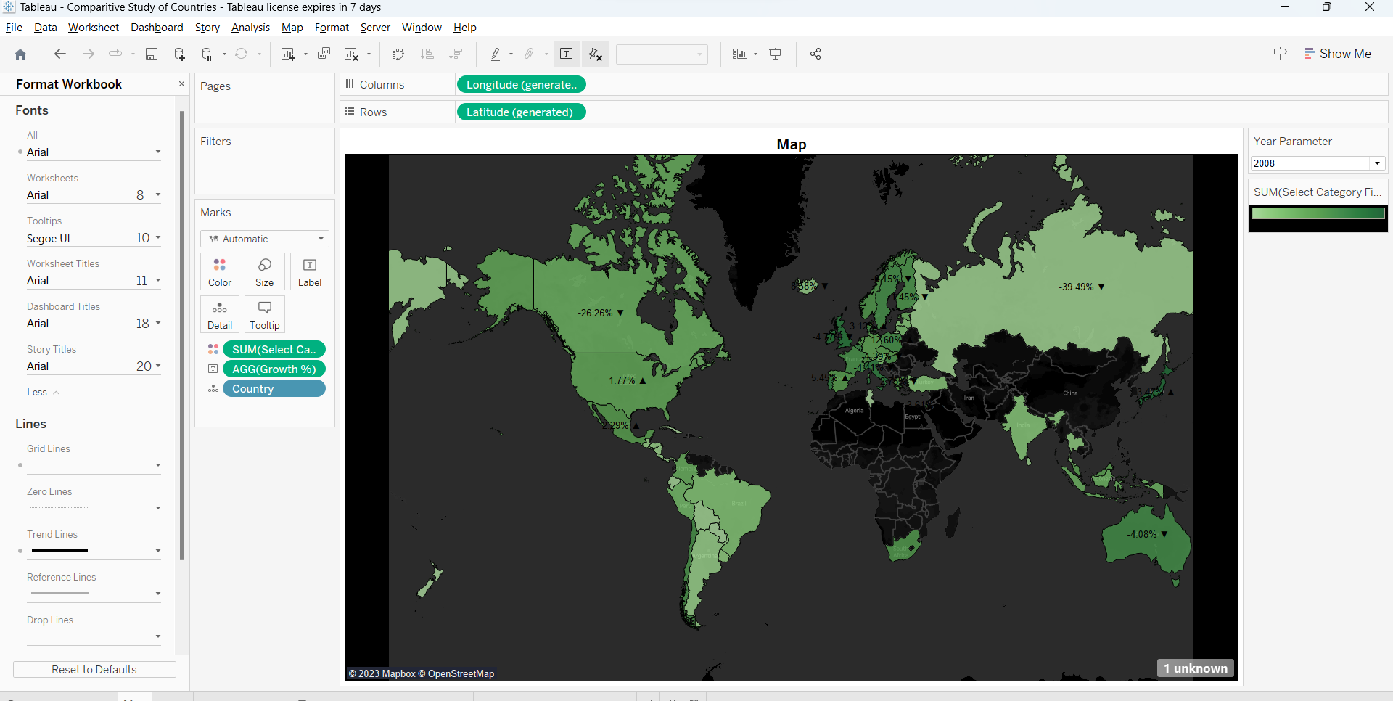

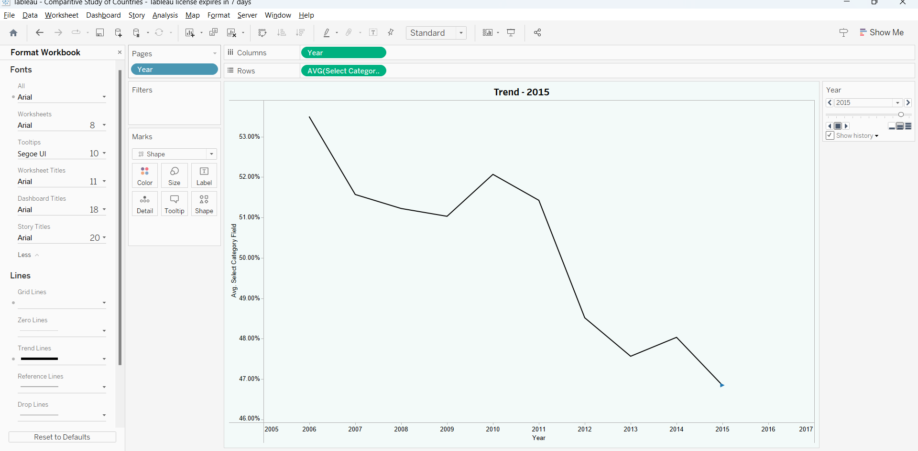

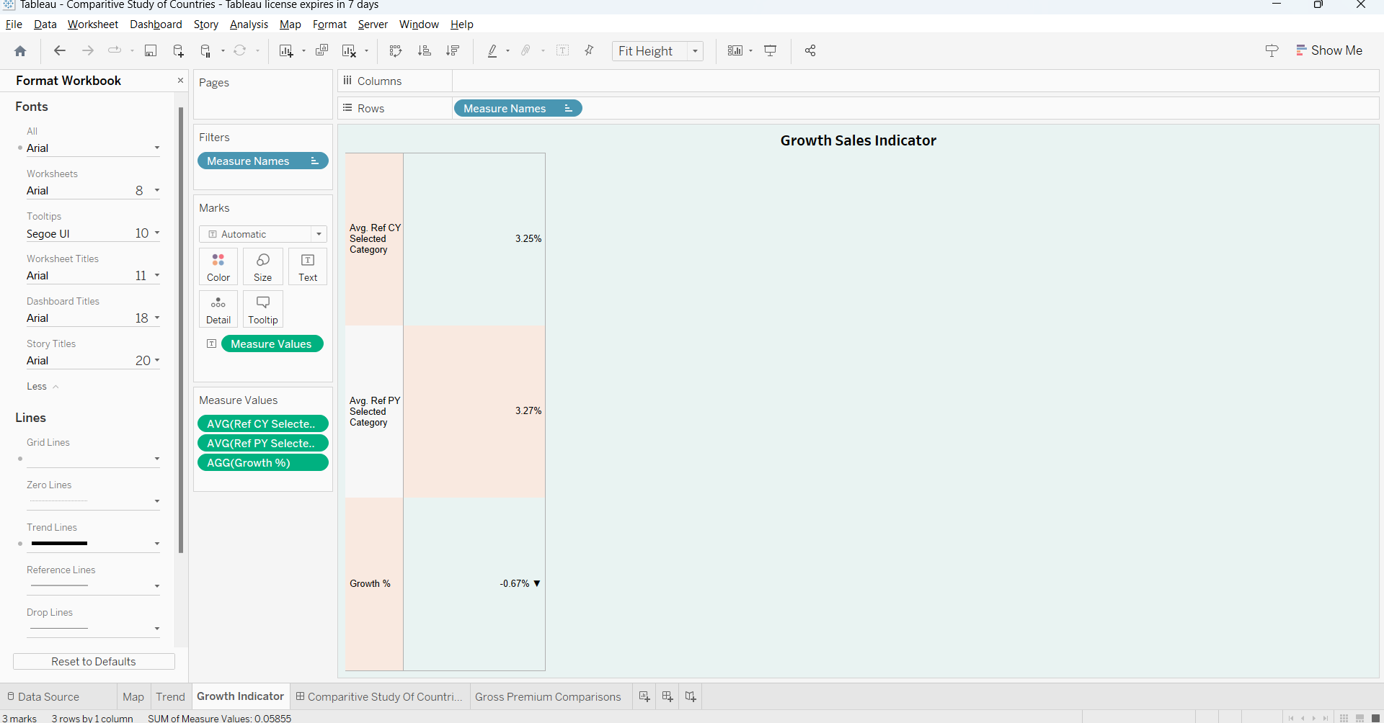

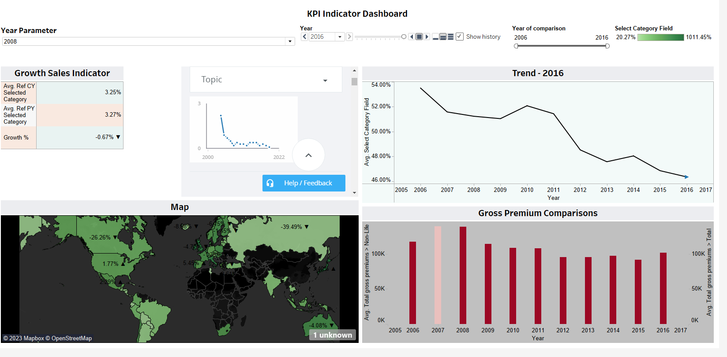

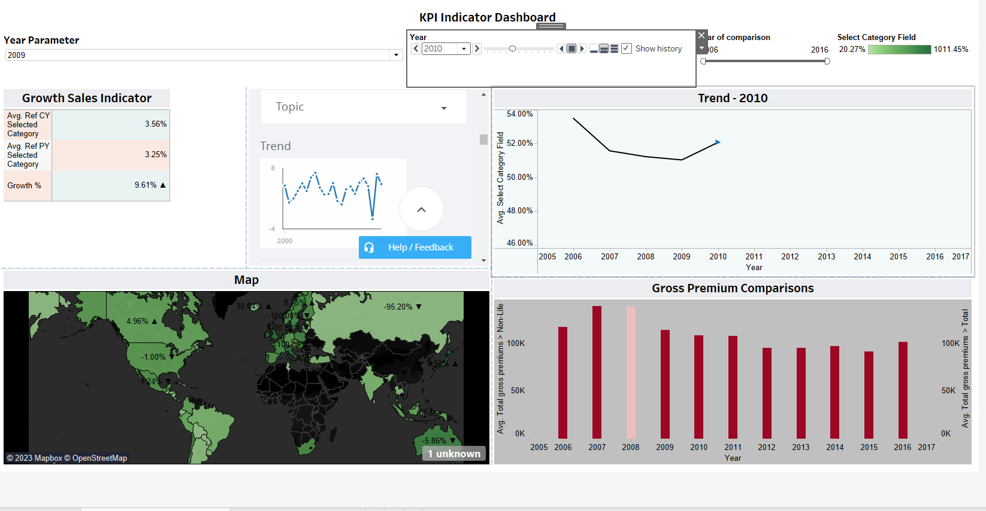



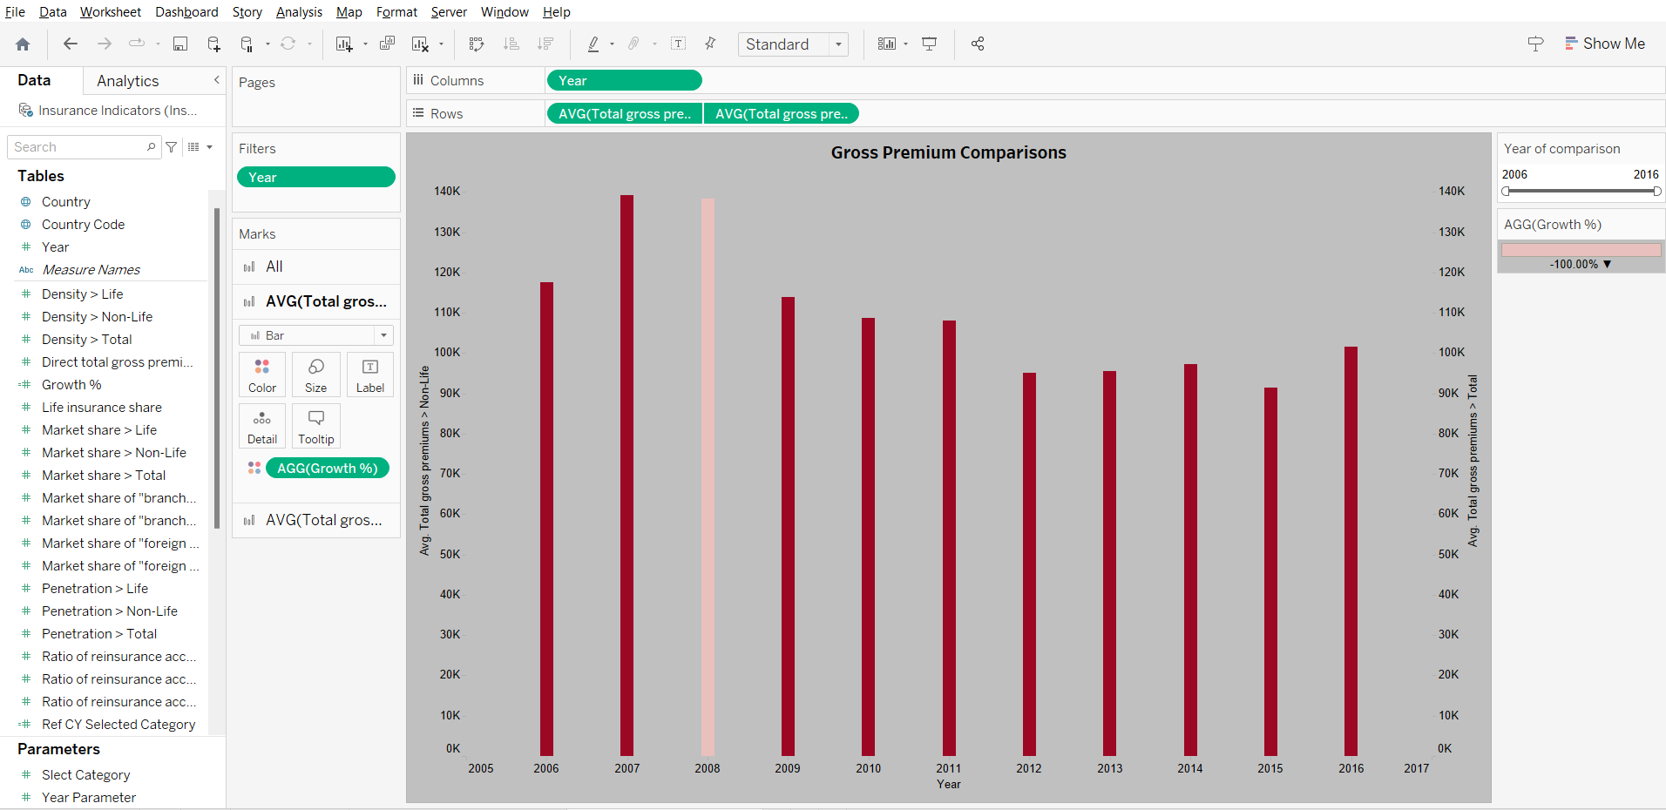

**Insights and Findings**

**Life insurance share Column:**

* The 'Life insurance share' column contains 478 data points.
* The mean life insurance share is approximately 0.494140, indicating that, on average, life insurance shares are around this value.
* The standard deviation is approximately 0.219185, suggesting some variability in the data.
* The minimum observed value in this column is approximately 0.001200.
* The 25th percentile is about 0.354848, and the 75th percentile is about 0.650687.
* The maximum observed value is 1.000000, indicating the highest life insurance share.

**Market share > Life Column:**

* The 'Market share > Life' column contains 355 data points.
* The mean market share for life insurance is approximately 0.030986, indicating a relatively low average market share.
* The standard deviation is approximately 0.069073, suggesting some variability in the data.
* The minimum observed value in this column is approximately 0.000010.
* The 25th percentile is about 0.001545, and the 75th percentile is about 0.018575.
* The maximum observed value is approximately 0.412070, indicating the highest market share for life insurance.

**Market share > Non-Life Column:**

* The 'Market share > Non-Life' column contains 362 data points.
* The mean market share for non-life insurance is approximately 0.030387, with some variability in the data (standard deviation: 0.104647).
* The minimum observed value in this column is approximately 0.000120.
* The 25th percentile is about 0.001703, and the 75th percentile is about 0.017352.
* The maximum observed value is approximately 0.670300, indicating the highest market share for non-life insurance.

**Market share > Total Column:**

* The 'Market share > Total' column contains 367 data points.
* The mean market share for total insurance is approximately 0.029973.
* The standard deviation is approximately 0.082900, indicating some variability in the data.
* The minimum observed value in this column is approximately 0.000030.
* The 25th percentile is about 0.001810, and the 75th percentile is about 0.018335.
* The maximum observed value is approximately 0.541520, indicating the highest total market share.
* Market share of "branches/agencies of foreign undertakings" in total domestic business > Life Column:

**The 'Market share of "branches/agencies of foreign undertakings" in total domestic business > Life' column contains 292 data points.**

* The mean market share for life insurance in this category is approximately 0.059057.
* The standard deviation is approximately 0.117669, suggesting some variability in the data.
* The minimum observed value in this column is 0.000000.
* The 25th percentile is 0.000000, and the median (50th percentile) is approximately 0.011985.
* The 75th percentile is approximately 0.047447, and the maximum observed value is approximately 0.647810.

**Market share of "branches/agencies of foreign undertakings" in total domestic business > Non-Life Column:**

* The 'Market share of "branches/agencies of foreign undertakings" in total domestic business > Non-Life' column contains 315 data points.
* The mean market share for non-life insurance in this category is approximately 0.070714.
* The standard deviation is approximately 0.113932, suggesting some variability.
* The minimum observed value is 0.000000.
* The 25th percentile is approximately 0.001365, and the median (50th percentile) is approximately 0.027940.
* The 75th percentile is approximately 0.081875, and the maximum observed value is approximately 0.538780.

**Year and Life Insurance Share:**

Correlation: -0.097965

Interpretation: There is a weak negative correlation between the year and life insurance share. The correlation suggests a slight decrease in life insurance share as the years progress.

**Market Share > Life and Market Share > Non-Life:**

Correlation: 0.912052

Interpretation: There is a strong positive correlation between market share in life insurance and market share in non-life insurance. This indicates that countries with higher market share in life insurance tend to have higher market share in non-life insurance as well.

**Market Share > Total and Market Share of "branches/agencies of foreign undertakings" in total domestic business > Life:**

Correlation: -0.100344

Interpretation: There is a weak negative correlation between market share in total insurance and market share of "branches/agencies of foreign undertakings" in total domestic business for life insurance.

**Penetration > Life and Penetration > Non-Life:**

Correlation: 0.248531

Interpretation: There is a moderate positive correlation between penetration in life insurance and penetration in non-life insurance. This suggests that higher penetration in one type of insurance is associated with higher penetration in the other type.

**Retention Ratio > Life and Retention Ratio > Non-Life:**

Correlation: -0.140554

Interpretation: There is a weak negative correlation between retention ratio in life insurance and retention ratio in non-life insurance. This implies that as the retention ratio in one category decreases, it tends to increase in the other category.

**Density > Life and Density > Non-Life:**

Correlation: 0.535001

Interpretation: There is a strong positive correlation between the density of life insurance and the density of non-life insurance. This indicates that countries with higher density in life insurance also tend to have higher density in non-life insurance.

**Direct Total Gross Premiums/Number of Employees of Insurance Companies and Total Gross Premiums > Life:**

Correlation: 0.114211

Interpretation: There is a weak positive correlation between the direct total gross premiums per employee of insurance companies and total gross premiums in life insurance. This suggests that countries with higher direct total gross premiums per employee may also have higher total gross premiums in life insurance.

Total Gross Premiums > Non-Life and Total Gross Premiums > Total:

Correlation: 0.985706

Interpretation: There is a very strong positive correlation between total gross premiums in non-life insurance and total gross premiums in the entire insurance sector. This indicates that the majority of premiums are contributed by non-life insurance.

**YEARLY STATISTICS**

* Life insurance share: The column has 478 data points with a mean value of approximately 0.494. It ranges from a minimum of 0.0012 to a maximum of 1.0000, with a standard deviation of about 0.219. The median value is around 0.503, and the data is moderately spread out, with 25th and 75th percentiles at 0.355 and 0.651, respectively.
* Market share > Life: This column contains 355 data points, with a mean value of roughly 0.031. It has a wide range from a minimum of 0.00001 to a maximum of 0.412, exhibiting variability with a standard deviation of approximately 0.069. The median value is around 0.007, and the 25th and 75th percentiles are 0.002 and 0.019, respectively.
* Market share > Non-Life: With 362 data points, this column has an average value of about 0.030, along with a high standard deviation of roughly 0.105. It ranges from a minimum of 0.00012 to a maximum of 0.670, indicating substantial variability. The median value is approximately 0.004, and the 25th and 75th percentiles are 0.002 and 0.017, respectively.
* In 2007, there was an increase in total gross premiums to around $4,592,370.
* 2008 saw a similar figure of about $4,566,576 in total gross premiums.
* The year 2009 recorded a slight decrease in total gross premiums, totaling approximately $4,326,066.
* In 2010, total gross premiums increased again, reaching roughly $4,454,069.
* 2011 witnessed a further increase in total gross premiums, totaling around $4,861,814.
* Total gross premiums in 2012 remained close to the previous year, at about $4,852,043.
* 2013 showed an increase, with total gross premiums amounting to approximately $5,065,836.
* In 2014, the total gross premiums rose to around $5,248,650.
* However, in 2015, there was a slight decrease in total gross premiums, totaling approximately $5,117,127.
* From this analysis, it's evident that there has been some variation in total gross premiums over the years, with occasional increases and decreases. The highest total gross premiums were observed in 2014, while the lowest were recorded in 2009. This information provides insights into the financial performance of the insurance company over this time period. Further analysis and context would be necessary to understand the factors driving these fluctuations.

**COUNTRY STATISTICSHere's a summary analysis of the provided data for the specified columns:**

* Life Insurance Share

The average life insurance share across countries ranges from approximately 0.15 to 0.79, with the highest in South Africa (ZAF) and the lowest in Turkey (TUR).Argentina (ARG) and Bolivia (BOL) have relatively low life insurance shares.

* Market Share > Life

The average market share for life insurance ranges from about 0.0006 to 0.3566, with the highest in the United States (USA).

Most countries have relatively low market shares for life insurance.

* Market Share > Non-Life

The average market share for non-life insurance varies from about 0.0006 to 0.6117, with the highest in the United States (USA).

Similar to market share for life insurance, most countries have relatively low market shares for non-life insurance.

* Market Share > Total

The average total market share ranges from about 0.0022 to 0.4780, with the highest in the United States (USA).

Again, most countries have relatively low total market shares.

* **Market Share of "Branches/Agencies of Foreign Undertakings" in Total Domestic Business > Life**

The market share of branches/agencies of foreign undertakings in total domestic business for life insurance varies, with some countries having significant shares (e.g., Turkey - TUR) and others having lower shares (e.g., the United States - USA).

* **Market Share of "Branches/Agencies of Foreign Undertakings" in Total Domestic Business > Non-Life**

Similar to life insurance, the market share of branches/agencies of foreign undertakings in total domestic business for non-life insurance varies among countries.

* **Market Share of "Foreign Controlled Undertakings" and "Branches/Agencies of Foreign Undertakings" in Total Domestic Business > Life**

The market share of foreign controlled undertakings and branches/agencies of foreign undertakings in total domestic business for life insurance also varies, with some countries having significant shares.

* **Market Share of "Foreign Controlled Undertakings" and "Branches/Agencies of Foreign Undertakings" in Total Domestic Business > Non-Life**

Similar to life insurance, the market share of foreign controlled undertakings and branches/agencies of foreign undertakings in total domestic business for non-life insurance varies among countries.

* **Penetration > Life**

The penetration of life insurance, on average, ranges from about 0.0035 to 0.0495, with higher values in Belgium (BEL) and the United States (USA).

**Conclusion**

The interactive dashboard and analysis provide a powerful tool to strategize market penetration and target new customers. By visualizing and comparing various parameters across countries, we can identify growth opportunities, assess income group dynamics, and make informed decisions regarding branch expansion. The integration of external data sources and interactive elements ensures that the dashboard is both informative and user-friendly, allowing for data-driven insights and efficient decision-making.